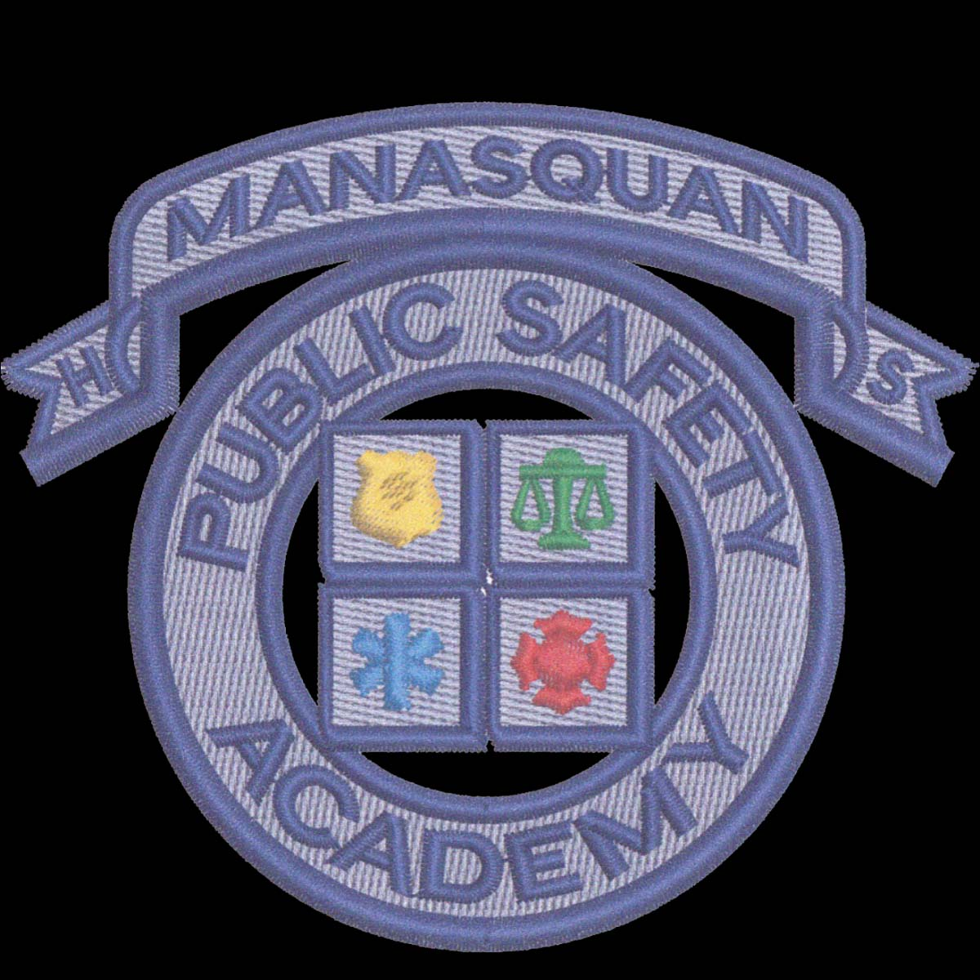**MANASQUAN HIGH SCHOOL**

**Academy of Law, Government, and Public Safety**

Co Directors: Capt. Tim Clayton, RET and Mr. James Fagen, J.D., M.A.

**About the Academy**

The Academy of Law, Government, and Public Safety creates a career interest pathway for students interested in careers in the practice of law, legislative work in the local, state, and federal government, law enforcement, fire service, and emergency services. Students interested in these fields are exposed to engaging and rigorous curriculum in elective choices to create a foundation in the career pathway in post-secondary or workforce opportunities.

Name:______________________________ Grade:___________________________

Address:_______________________________________________________________________

Home Phone Number:____________________________________________________________

Student’s E-mail:________________________________________________________________

Parent/Guardian’s E-mail:__________________________________________________________

What are your career goals? How will being a member of this Academy help you reach those goals?

What is your current grade point average?

Please provide three teacher’s names that could provide a reference for you to join the Public Safety Academy:

1. ___________________________
2. ___________________________
3. ___________________________

I understand that if I am accepted into this program, I will need to course requirements and finish with a “B” average or higher in each class. I further understand that if ANY disciplinary issues or academic integrity issues should occur during my time at Manasquan High School, my participation in the program could be reviewed and may result in me being asked to leave the Academy of Law, Government & Public Safety. My acceptance further commits me to be a program participant during my entire senior year.

___________________________________________

Applicant’s Signature Date

I have read the application and approve of my child’s participation in the MHS Public Safety Academy, if he/she is selected.

___________________________________________

Parent/Guardian Date

**Proposed Course of Study**

**To graduate from the Academy, you must take a minimum of 15 credits and finish with a B average in all of them. Any disciplinary issues or academic integrity issues will result in you being removed from the Academy.**

Courses

All courses are 2.5 credits

Law and Government Public Safety

Civil Action & Democracy Criminal Investigation

Historical Research & Debate Public Safety

Introduction to Law Introduction to Law

Constitutional Law Constitutional Law

Introduction to Criminal Justice* Introduction to Criminal Justice*

Introduction to Criminology* Introduction to Criminology*

AP Government (5 Credits) Public Safety Careers (Senior Year)

*Denotes courses that are dual enrollment courses through Brookdale Community College. Students MUST be a junior or senior to take these courses.

**If you should have any questions about the Academy of Law, Government & Public Safety, please contact Mr. Clayton (**[**tclayton@manasquanboe.org**](mailto:tclayton@manasquanboe.org)**) or Mr. Fagen (**[**jfagen@manasquanboe.org**](mailto:jfagen@manasquanboe.org)**).**